Unity3D Canvas

Created: 20 October 2019 Updated: 20 October 2019

Table of Contents

Canvas Settings 0

Codes 0

## Canvas Settings

## 

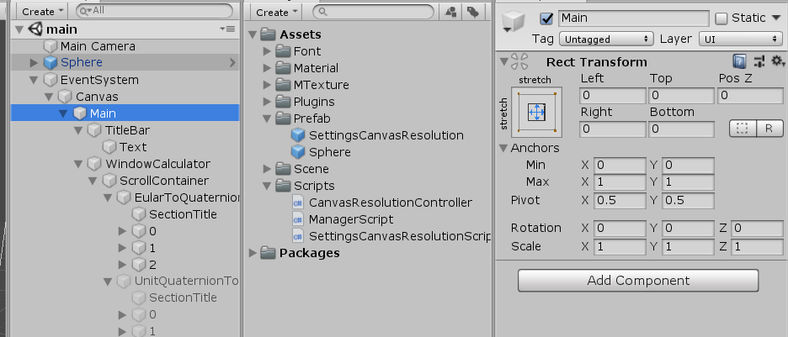

* 3 layers of hierarchy is used instead, EventSystem -> Canvas -> Main
* At any point in time in Game, Canvas **referenceResolution** should not need to be change at all throughout the entire lifetime of the program, only needed to be set ONCE. This is why 1920x1080 Resolution is chosen

## Codes

When dealing with Canvas/UI, canvas’s **referenceResolution** should be used instead to get desired results

